Launch EC2 instance

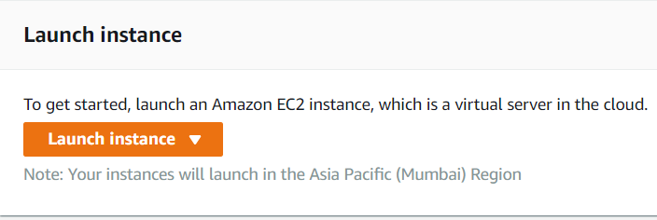

Click on ***Launch Instance***

We have 7 steps to Launch EC2 instance

Step 1: Choose an Amazon Machine Image (AMI)

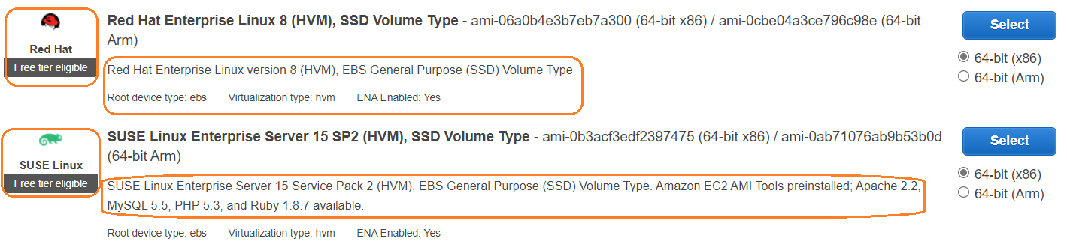

Few AMI will have plan ami (software’s are not installed) and few AMI will get inbuild software’s